ONLINE DRESSAGE SHOWS

Team Rankings (after June 2026 show)

Category A (9 or more combinations)
1 |  | Cullen Stables | 12 671

Category B (8 or less combinations)
1 | 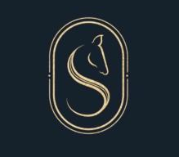 | Team Slater | 3 498
2 |  | Misty Morn Farm | 1 924
3 |  | True Contact Equestrian | 1 326
4 |  | Stunoverian Equestrian | 1 320
5 | 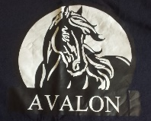 | Avalon | 250
6 |  | Serene Valley Equestrian | 170
7 |  | Bakenveld Equestrian | 158

